My Link to the Website: My Weather App
STRENGTHS: My new architecture benefits are obvious. Suddenly, our app is not entirely reliant on the Open weather Map API. Because, it has its own data, it has its own database, and we are fetching from our own database. And thousands of users were fetching from closer. Also, we can build our own data chart for different cities. Sometimes, the Open weather Map was going to stop working and it happens uptime is only 90% or sometimes, 95%. But it always displays the freshness. So, we just now wait the data from five minutes ago. We have the local data, and we can display data and, we can describe here is the data. Now, we are fetching closer. So, we can say that it has performance implications. We can also see times and date. From that, thousands of users were fetching from closer and building their own data. By creating this proper and perfect app where people have their favorite cities, and we get the fresh weather information and, we are fetching for my database in SQL after refresh every ten second and it imports and view fresh weather information, and we also inform others about the weather. We can build level five, six modules where we build database driven applications. We could also hit our own database with our own data. In this prototype two app’s architecture we also got our visible API key in the JavaScript. Api key is not visible for anyone else trying to hack it, as it protects the client’s information, data and it also prevents from it being infiltrated.
PERFORMANCE COMPARISON OF IMPROVE ARCHITECTURE
- One strengths of my applications architecture are the performance. Compared to the prototype one, this new and improved version performs much better than its predecessor. This can be clearly seen below my screenshots, which shows that the time taken for the files in prototype two is much faster than the prototype1. This is likely because prototype one fetched data from Luton whereas prototype two fetches’ data from the less. This enhancing the performance of my architecture. And this trend in performance follows in the Largest Contentful Paint (LCP).

Prototype1: 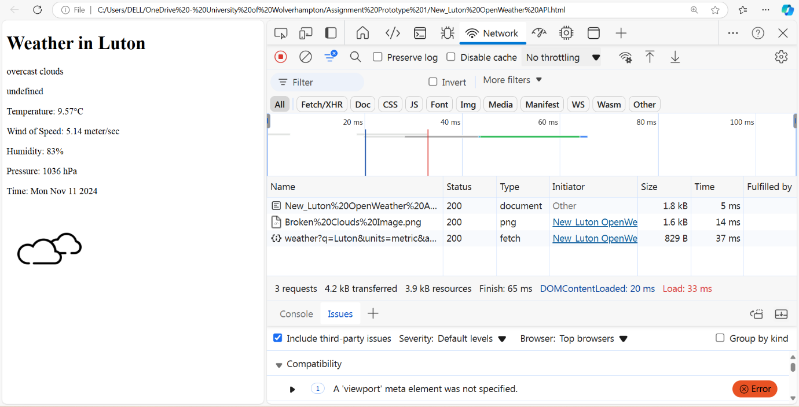
Prototype2: 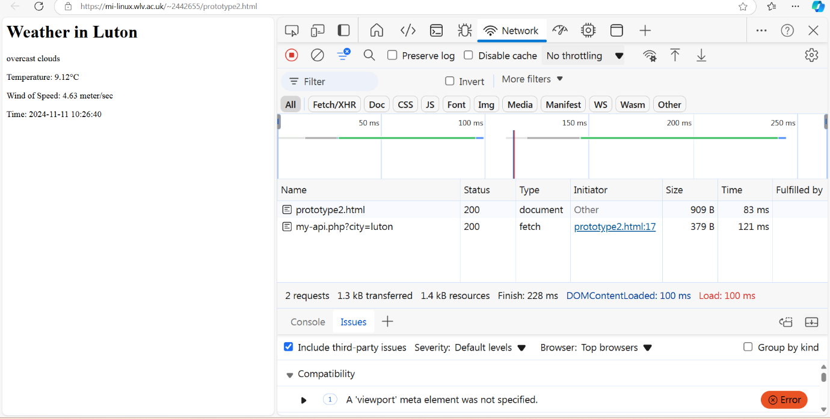

WEEKNESSES: It is obvious that it has happened with a problem to the server. Because we must take on our own hosting in a small database where there are couple of PHP scripts, and we must need somewhere to host it. We get it on mi-linux for free. It is not a great server and has not worked up well in real life. we had had to for hosting. And the price depends on what performance we want. For example, it could be traditional hosting, it would be cloud hosting, but there would be a cost involved. We have our own server like we have and there is a massive complexity involved. It does not work sometimes it did not work for a whole week. It might stop working repeatedly at some point. That is why we need an admin escort. The admin of analytics is incredibly good but it’s just too much busy. As a result, it crashes an hour before the deadline. The server and the team are very busy, and I think our own server has got a cost associated to it as the complexity scales, but we might not have to look out for the server risk as well. We are not storing anything sensitive here but when we start storing user accounts and user E-mails, possibility we will get hacked. And what about our GDPR? GDPR means General Data Protection Regulation because we are storing data right now, but data is not a trivial thing in 2024 these days. There’s a risk associated to it. We will get hacked and unknown people will try and hack my website. This app has massive complexity cost involved because of the server. Example, in prototype one we got that it has four lines of code. The user to chief the same thing really. Now, in prototype two, we have got 20 to 30 lines of code.
In short, prototype one architecture was good enough, but prototype two architecture is much better in many ways. Because we got the skills at this stage.

